**A**

**SOFTWARE REQUIREMENT SPECIFICATION**

**ON**

**PROJECT NAME**

**UNDER**

**NON-SYLLABUS PROJECT**



**Submitted To: Submitted By:**

**MS Ramandeep Kaur Kunal Jhalani (PIET20AD026)**

**Jay Yadav (PIET20AD021)**

**Prince Goswami (PIET20AD038)**

DEPARTMENT OF COMPUTER ENGINEERING

POORNIMA GROUP OF INSTITUTIONS, JAIPUR

(Academic Year 2021-22) (Odd)

|  |  |
| --- | --- |
| **FRONT PAGE Norms, Spiral Binding As above** | |
| **Chapter 1:Introduction of Project** | Font Size 12,Times new Roman,Spacing 1.5, |
| 1.1 Objective of Project | Font Size 10,Times new Roman,Spacing 1.0, |
| 1.2.Types of users | Font Size 10,Times new Roman,Spacing 1.0, |
| 1.3 Constraints and Dependency | Font Size 10,Times new Roman,Spacing 1.0 |
| 1.4 Methodology Used  **(Waterfall Model)** | Font Size 10,Times new Roman,Spacing 1.0, |
| **Chapter 2:Requirement Analysis** | Font Size 12,Times new Roman,Spacing 1.5, |
| 2.1Functional Requirement | Font Size 10,Times new Roman,Spacing 1.0, |
| 2.2 Non functional Requirement | Font Size 10,Times new Roman,Spacing 1.0, |
| 2.3 Technology Used | Font Size 10,Times new Roman,Spacing 1.0, |
| 2.4 H/w Configuration | Font Size 10,Times new Roman,Spacing 1.0, |
| 2.5 Graphical User Interface | Font Size 10,Times new Roman,Spacing 1.0, |
| **Chapter 3:Design** | Font Size 12,Times new Roman,Spacing 1.5, |
| 3.1 DFD | Font Size 10,Times new Roman,Spacing 1.0, |
| 3.2 UML | Font Size 10,Times new Roman,Spacing 1.0, |
| **Chapter4:Conclusion** | Font Size 12,Times new Roman,Spacing 1.5, |
| **Chapter5:References** | Font Size 12,Times new Roman,Spacing 1.5, |
| **Chapter6:Snapshots of Your project** | Font Size 12,Times new Roman,Spacing 1.5, |
| **Chapter 7:Code**  **(Sample of one -two page)** | Font Size 12,Times new Roman,Spacing 1.5, |

|  |
| --- |
| **DECLARATION**  I hereby declare that the Non syllabus Project report entitled “ATM machine system" was carried out and written by me under the guidance of MS Ramandeep Kaur, Assistant Professor, Department of Computer Engineering, Poornima Institute of Engineering & Technology, Jaipur. This work has not been previously formed the basis for the award of any degree or diploma or certificate nor has been submitted elsewhere for the award of any degree or diploma.      Date: 07/01/2022 Student Name:  Kunal Jhalani (PIET20AD026)  Jay Yadav (PIET20AD021)  Prince Goswami (PIET20AD038) |

**Introduction of Project**

**Objective of Project**

ATM is computerized telecommunication device that provides a financial institution’s customers a secure method of performing financial transactions, in a public space without the need of a human bank teller. Through ATM, customers interact with a user-friendly interface that enables them to access their bank account and perform various transactions.

**Scope and Purpose**

This software offers benefits such as cash withdrawals, balance transfers, deposits, enquiries, credit card advances and other banking related operations for customers. It also allows the administrator to fix the tariffs and rules as and when required.

This is intended for developers for purpose of maintaining and new release of the software, management of the bank, documentation writers and testers.

**Feasibility Study**

**Technical feasibility**

This project is technically feasible in every manner, all we need to do is login with our details and then we can select our preferred language. User can then select his account type i.e., current or saving account. He can then select weather he wants to deposit or withdrawal his money and the same amount he mentions there. User can also do balance transfer and balance enquiry. The project does not need any maintenance cost or any transportation cost as well.

**Requirement Analysis**

**User Interface requirement**

A login screen, Transaction System, Admin login, Balance Check

**Hardware requirement**

ATM machine with 220V manual switch.

ATM card

Card reader shall be a magnetic strip reader with smart card options.

**Design**

**Flow Chart**

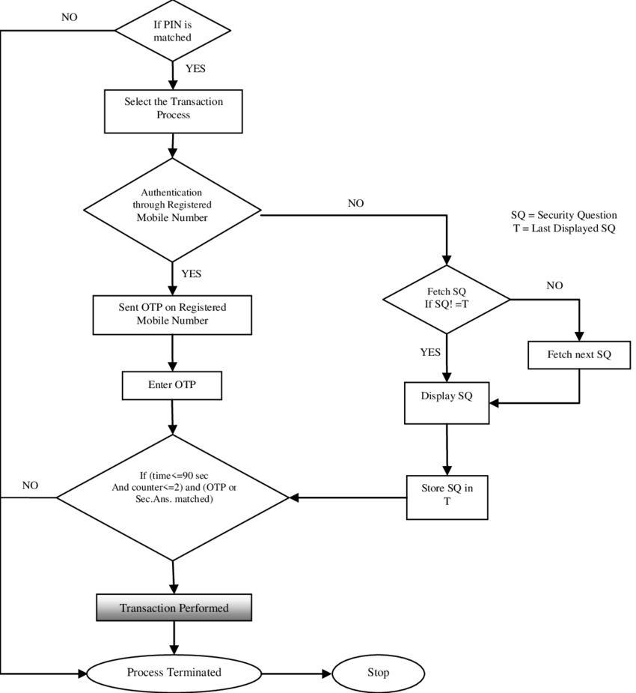

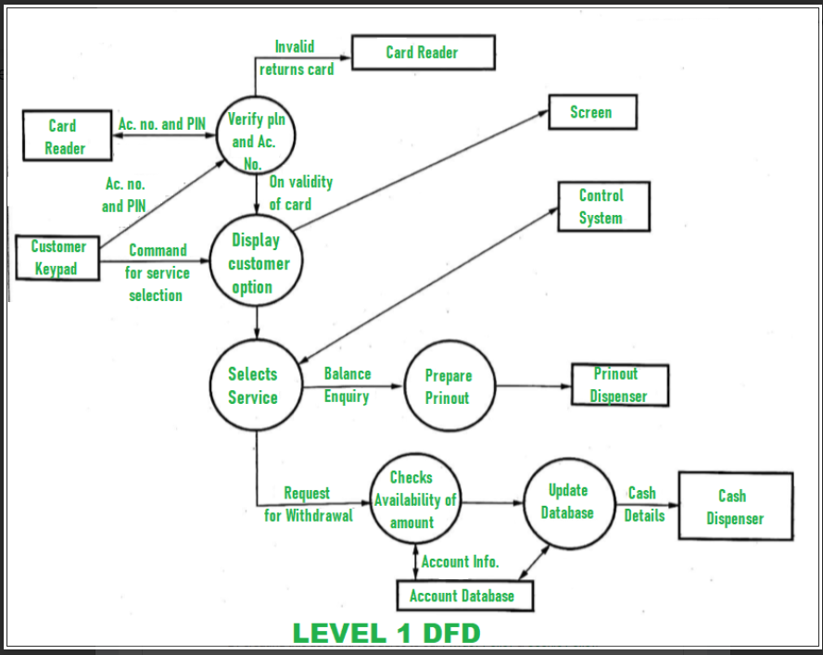

**Level 1 DFD**

**Maintenance**

**Cost Estimation**This project is an example of a one-time investment.

SECURITY

The system should have mechanism of self-monitoring periodically in order to detect any fault

**Future Application**

1. This will help keep transaction records and balance of large institutions and organizations.
2. This will help keep basic information of individuals.

**Conclusion**

The primary objective is to produce quality software. As the quality of a piece of software is difficult to measure quantitatively, we will judge it by its consistency and all the test cases.

**References**

<https://www.conceptdraw.com/examples/flow-chart-of-an-atm-machine-process>

https://itsourcecode.com/uml/atm-system-dfd-levels-0-1-2-best-dataflow-diagrams/

SNAPSHOTS of WEBSITE

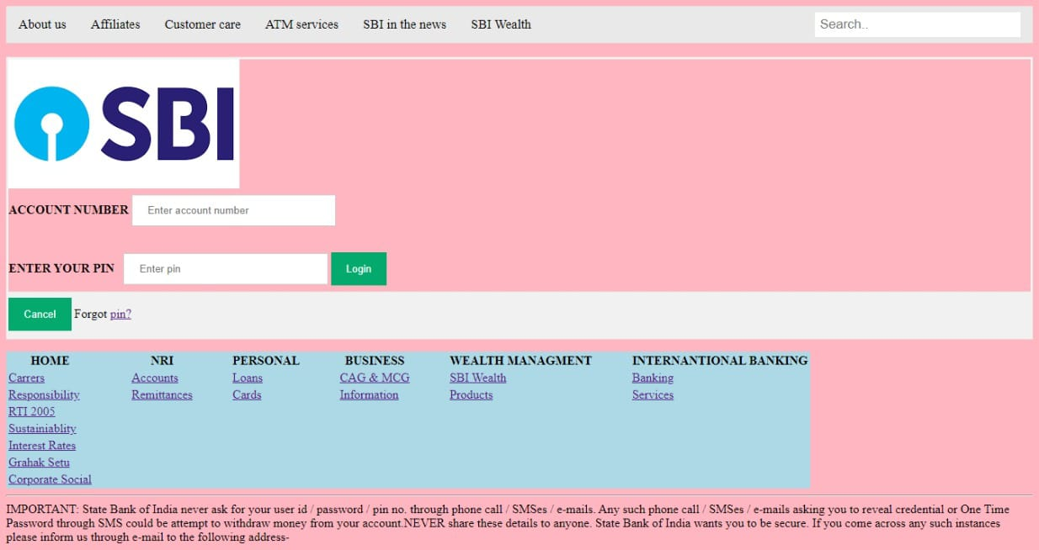

CODE